November 2020

Submission to the House Standing Committee on the Environment and Energy – Climate Change Bill 2020

Introduction

The Coalition for Community Energy welcomes the Climate Change Bills 2020. Indeed, tackling climate change has been the main motivation for community energy groups to form and to drive the development of local renewable energy projects.

**The Coalition for Community Energy (C4CE) represents the network of 105 community energy groups from around Australia.**

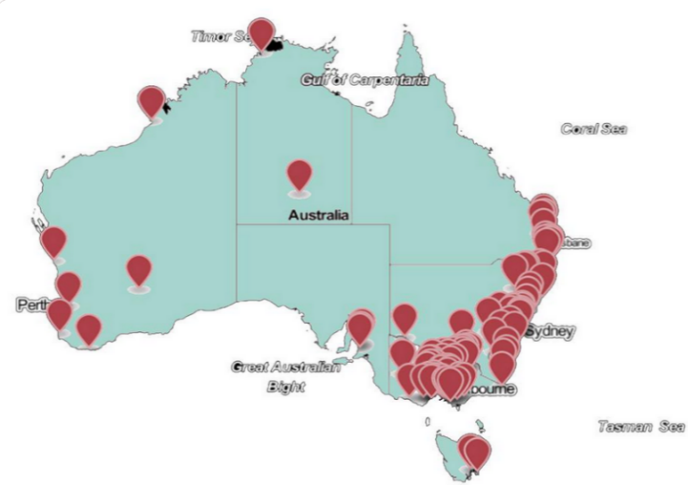

*Image by Community Power Agency cpagency.org.au*

Community energy is growing in Australia and internationally and is contributing to energy sector reforms globally[1]. Responsive policies and programs, particularly by the New South Wales and Victorian State Governments have enabled communities to learn about community energy and form organisations and partnerships to plan projects that will benefit them. These programs have unlocked a massive volunteer effort across the country that strengthen local economies, grow clean energy capacity and improve the social license of renewables.

The community energy sector would welcome stronger Federal Government support and recognition of the direct role communities play in moving toward a safe climate future. Community energy supporters across Australia hold diverse political views but we all share a vision of rapid deployment of clean energy technologies and empowered communities. The following comments attempt to capture the sentiments of our members.

Key Points

At this early stage in your inquiry we would like to make the following key points in relation to the Bills:

* The lack of consistent commitments with a strong framework to ensure implementation has hampered the community energy sector’s efforts at climate change action, particularly over the last 6 years as the sector has grown. The Climate Change Bills will go some way to improving that situation.
* Long-term and interim emissions reduction commitment are essential, especially to reorient the energy sector toward inevitable change and encourage energy businesses to see the merits of community energy.
* Many in our sector would highlight that the Net Zero target proposed for 2050 is inadequate. The global climate challenge needs industrialised nations like Australia to solve achieve zero-emissions in many sectors much faster than 30 years from now. 5 year budgets come closer to working appropriately with an energy sector that is undergoing enormous upheaval and with the right political signals could make substantial progress on achieving net zero emissions within the next decade.
* Climate change risk and adaptation assessments for many communities will demonstrate the need for resilient energy supplies and access to energy in times of crisis – many of which are precipitated by climate related events. This summer’s bushfires have demonstrated the unpreparedness of our electricity networks and the difficulty of importing fuel into communities in the immediate aftermath of a bushfire. Communities that have been impacted are now very aware of the benefits community energy can provide and are starting to take the lead themselves in planning for their own long term energy security.
* An independent authority for science based decisions is an important element of the proposed Climate Bill. Our sector shows everyday that there is value in climate action that is based on real community values and experiences and remains non-partisan.
* The Coalition for Community Energy has endorsed the Local Power Plan proposed by the independent member for Indi, Helen Haines and many community energy groups wrote individual submissions to that process. The plan highlights the benefits that can be delivered if energy technologies are developed to best suit the local scale. Our sector’s support for the Plan demonstrates our confidence that community energy approaches will deliver a beneficial energy transition and create the necessary social license for new technology during that journey.
* The Climate Change Bill proposes a principle of community engagement and self determination. Community energy showcases this principle in action. The market players and government policies guiding the energy sector are enhanced by community energy projects and active participation of communities in energy transitions.
* We recommend that knowledge of the energy sector and its pace of transition will be an important skill set to recruit for the climate change commission. The existence of the community energy sector as a relative outsider to the energy sector demonstrates the importance of actively engaging with alternative visions of the future during transition. Any energy sector expertise that is recruited must also include experience and curiosity about the benefits community energy delivers.

Benefits delivered community energy

We hope the following examples of the benefits delivered by community energy encourage the committee to ensure that the Climate Change Bills are passed in a way that support communities around Australia to participate in delivering necessary climate emissions reductions.

**Unlocking the benefits communities want**

The community energy sector has been showing, for over a decade, that energy markets don’t unlock many of the long term benefits that communities want. Community energy groups have been at the forefront of driving:

* a faster transition to a zero carbon electricity system
* local ownership and control of energy assets
* energy efficiency, working with all consumers to improve energy costs and usage
* zero carbon community planning - empowering consumers to participate
* local job creation, regional investment and allowing communities to benefit from their own resources

**Community participation in energy decision making**

The community energy sector exists because more than 100 community groups around Australia believe in a different vision of our energy system and are setting about creating it. An essential common feature of community energy projects is that they are governed differently. C4CE expect to see community voice and local governments having an increasing influence in energy decision making as our sector grows.

Many community energy groups are tackling climate change beyond electricity-based projects and are looking at zero-net energy and zero-net emissions solutions for their whole community. The transition to zero carbon heat, transport, food, water and land use cannot be driven simply by market signals. It can be heavily influenced by community action plans and community practices.

**Benefits the market cannot deliver alone**

**Social license:** Community energy creates social license, shared vision and empowered communities. An energy sector operating at the whim of new demands will struggle, whereas a sector working with its communities can be more prescient in meeting consumer expectations.

**Overcome market failures:** Energy efficiency and demand management can be the cheapest ways to free up energy volume and capacity but suffer from various market failures in developing the opportunity. Community energy groups have shown a willingness to engage in the information delivery and technical support required to help consumers reduce energy bills through simple actions. Communities, governments and markets need to work together to realise the full economic benefits of efficiency and demand management resources, but doing so would contribute greatly to the resource adequacy challenge.

**Equity:** Community energy groups continue to experiment with policy development, programs and projects to offer a “renewables for all” vision to their communities. Many within the sector recognise that the energy transition necessarily involves everyone and is currently driving inequality and increased disadvantage for some. An equity ambition has lead to initiatives such as the solar gardens project to offer solar energy to renters and Centrelink-based financing to make solar accessible to low-income consumers.

**Shared ownership of the system:** The energy industry continues to imagine itself with sole responsibility for meeting energy needs, managing variability, capital replacement and integration of renewables. The largest investment of recent times, of course, is the rooftop solar powerstation that sits on everyone’s rooves. Community energy projects can provide both market and community benefits. They can fix network problems and serve local needs at the same time. Shared ownership and management may well be the cheapest way to contribute to dual goals and support both the system and the consumers. Business cases developed across the energy sector rarely explore the possibility of sharing their problems and solutions with the communities who are intimately impacted by their decisions.

1. Since 2015, three community energy practitioners have been awarded Churchill Fellowships to investigate international developments in energy transitions and community energy. Their reports can be found here:

   [Taryn Lane – Transitioning regional towns to 100% renewable energy](https://www.churchilltrust.com.au/project/to-transition-regional-australian-towns-to-100-renewable-energy-by-learning-from-european-examples---germany-denmark-austria-sweden-uk/)

   [Chris Cooper – Transforming the community solar sector](https://www.churchilltrust.com.au/project/to-transform-australias-community-solar-sector-by-learning-from-the-worlds-leading-community-energy-organisations---usa-uk-germany/)

   [Heather Smith – Governance structures in community energy schemes](https://www.churchilltrust.com.au/project/to-identify-robust-governance-structures-in-community-energy-schemes---japan-germany-denmark-uk-usa/)