November 2020

Submission to the House Standing Committee on the Environment and Energy – Climate Change Bill 2020

***Add your own image – showcase your community energy work***

**Organisation:**

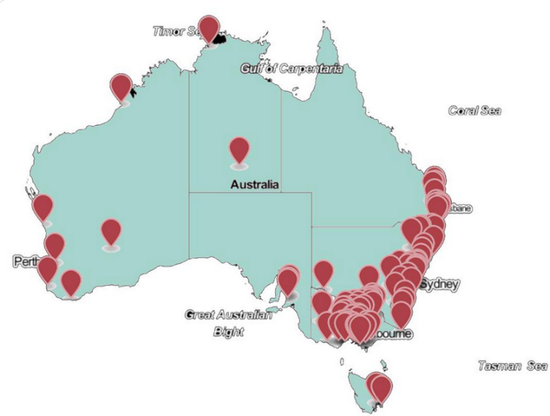

*Image by Community Power Agency cpagency.org.au*

**Location:**

Our organisation was formed to…

The Climate Change Bills will go some way toward helping us meet our commitments and to supporting our community as we tackle climate change.

*What do you think of the Net Zero by 2050 target and the importance of having a long term target?*

*What can 5 year budgets do to drive change – particularly in the energy sector?*

*Will climate change risk and adaptation assessments affect your community and/or your community energy projects?*

*From your interaction with community members – how ready do you think they are to respond to technological change?*

*The following guiding principles all sound wise – what, in your own model of community energy governance, shows how your organisation applies these sorts of principles or any one in particular?*

* Principle of effective, efficient and equitable action
* Principle of informed decision making
* Principle of risk-based, integrated decision making
* Principle of fiscal responsibility
* Principle of fair employment transition
* Principle of community engagement and self-determination
* Principle of national and international cooperation